Model Training Evaluation Metrics

# Comparison by Learning Rate

Train Loss by Learning Rate

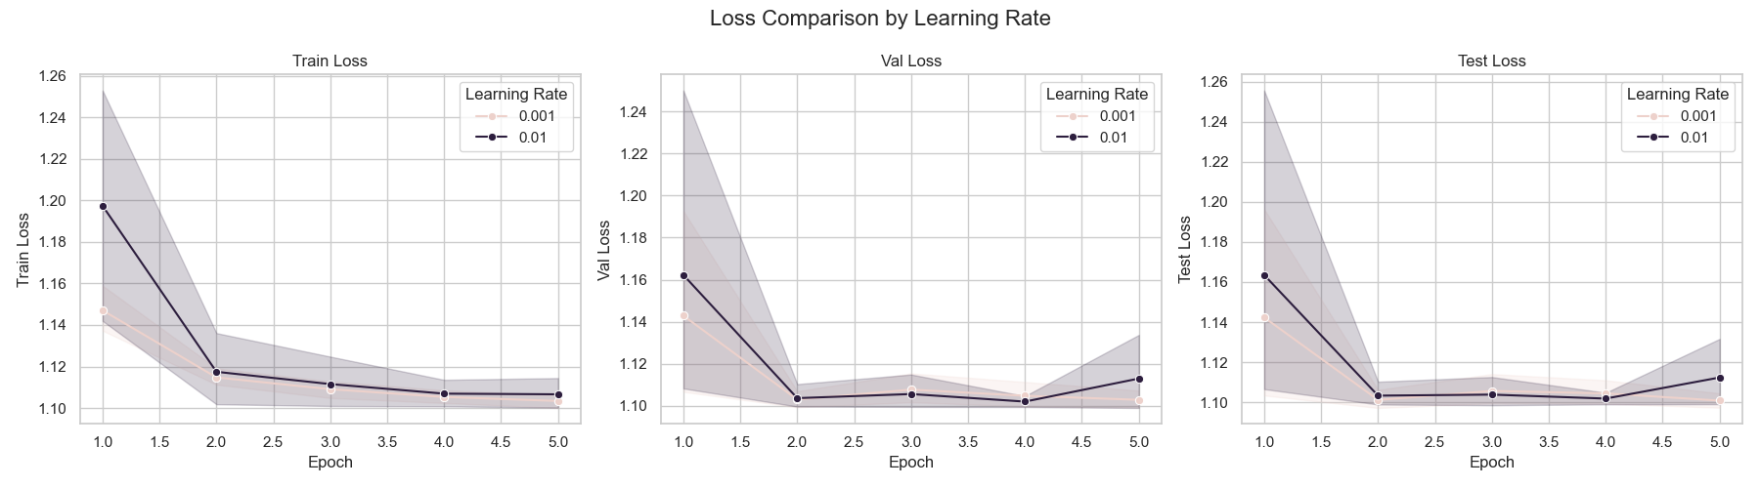

Train Acc by Learning Rate

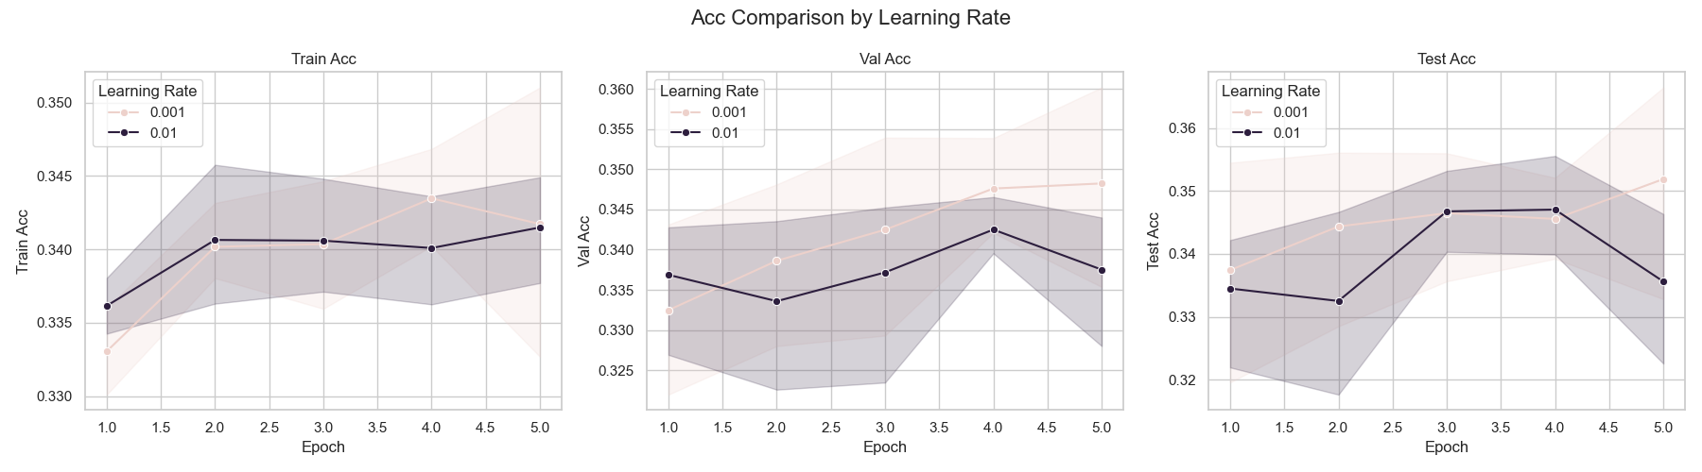

Train Precision by Learning Rate

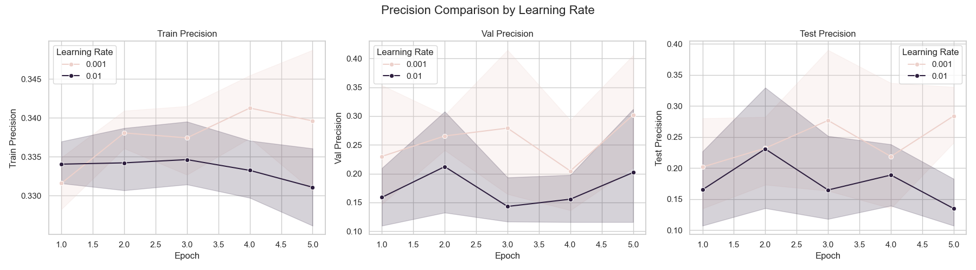

Train Recall by Learning Rate

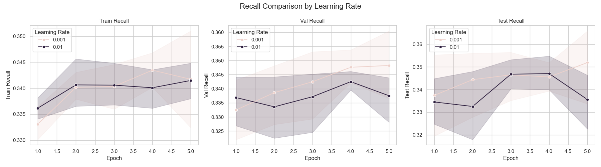

Train F1 Score by Learning Rate

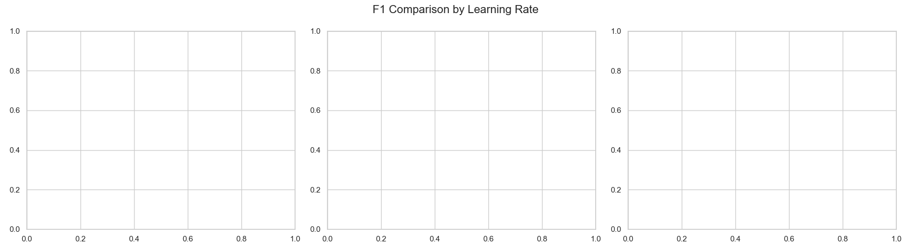

Train ROC AUC by Learning Rate

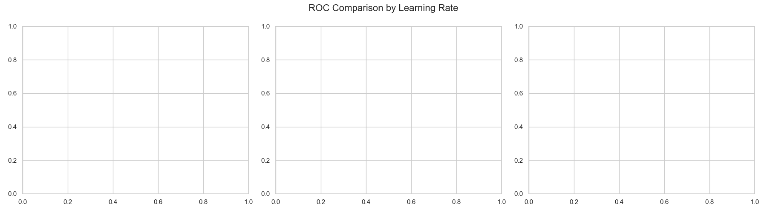

Train RMSE by Learning Rate

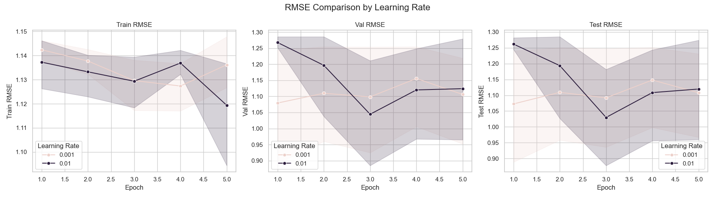

# Comparison by Batch Size

Train Loss by Batch Size

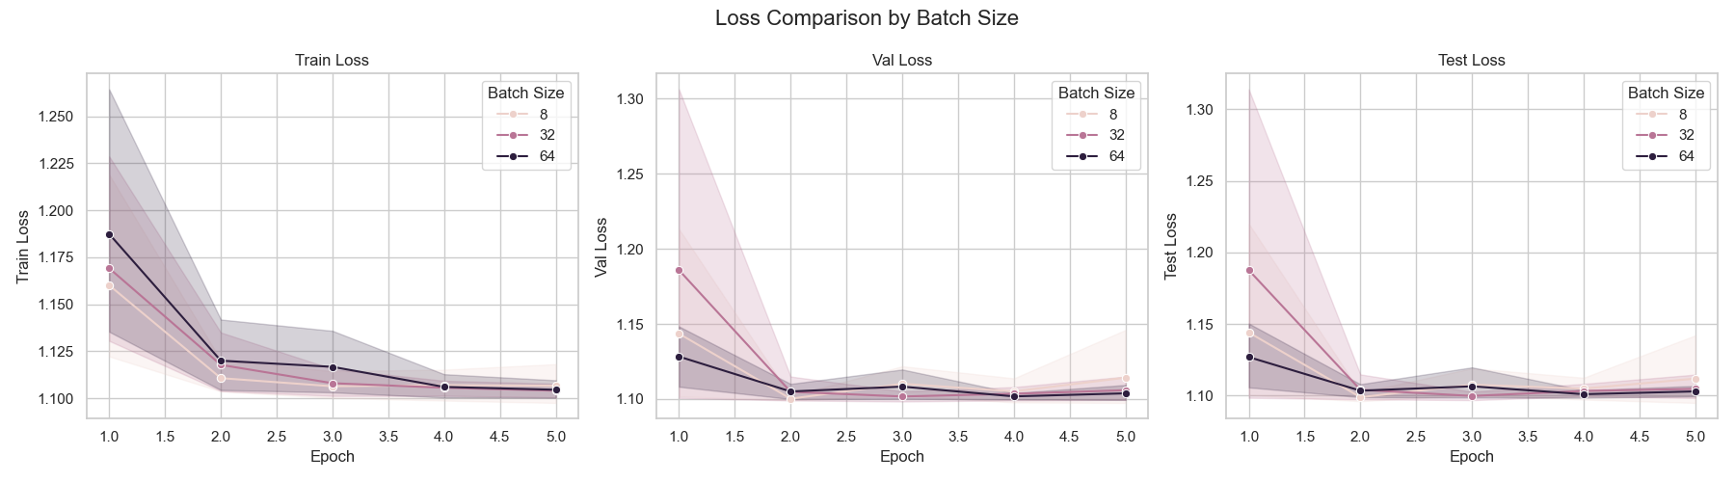

Train Acc by Batch Size

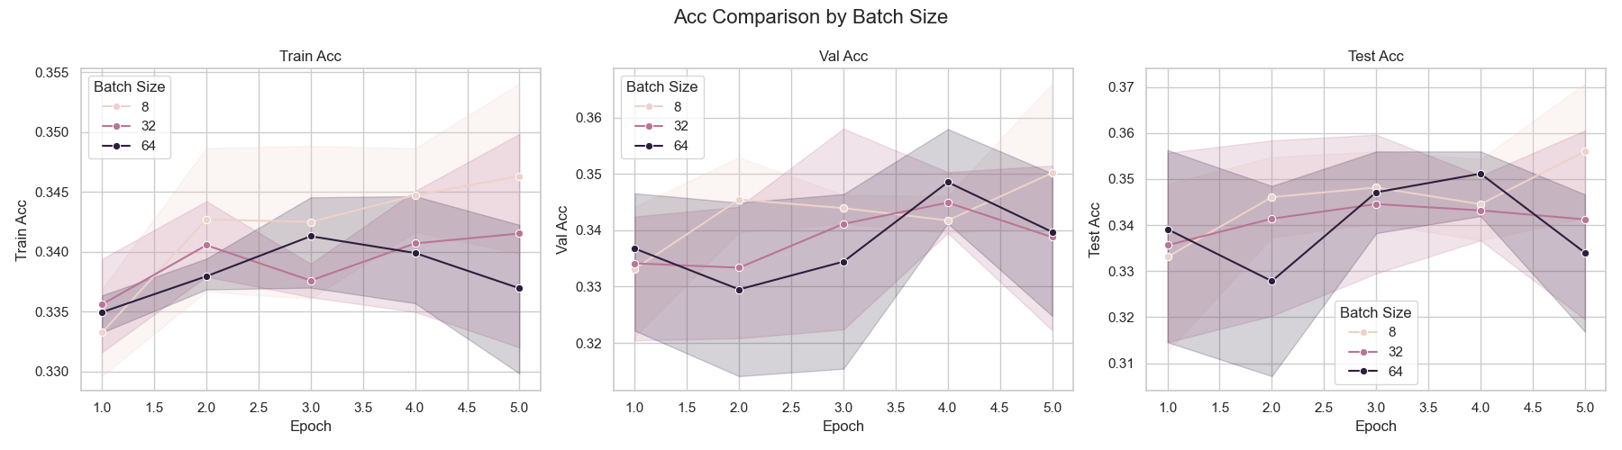

Train Precision by Batch Size

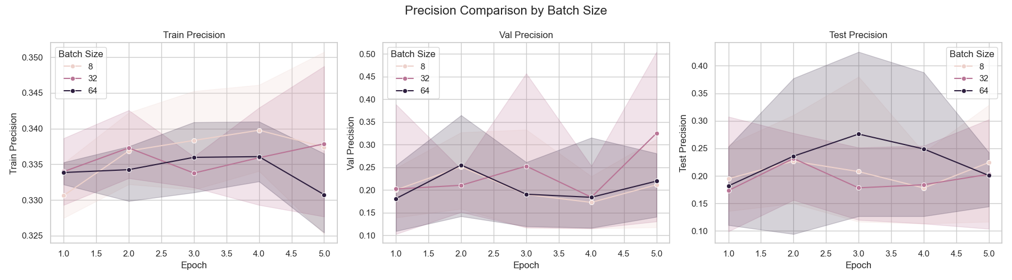

Train Recall by Batch Size

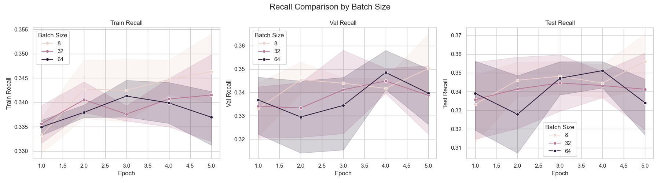

Train F1 Score by Batch Size

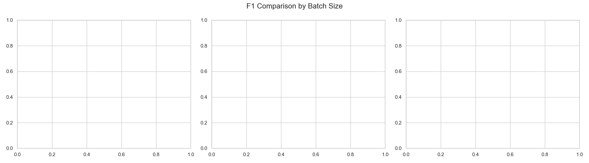

Train ROC AUC by Batch Size

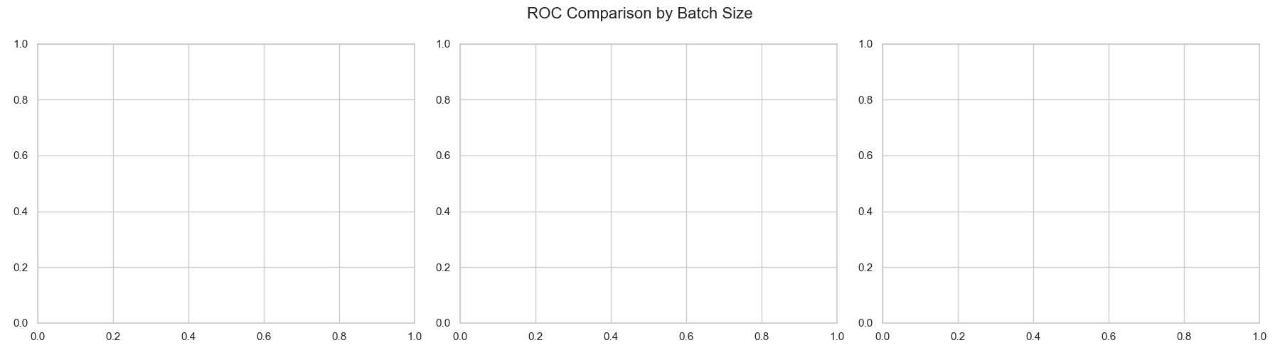

Train RMSE by Batch Size

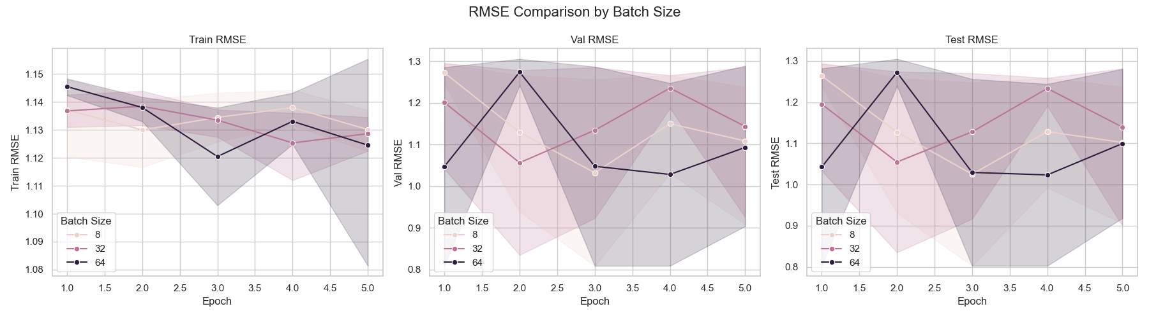

# Comparison by Optimizer

Train Loss by Optimizer

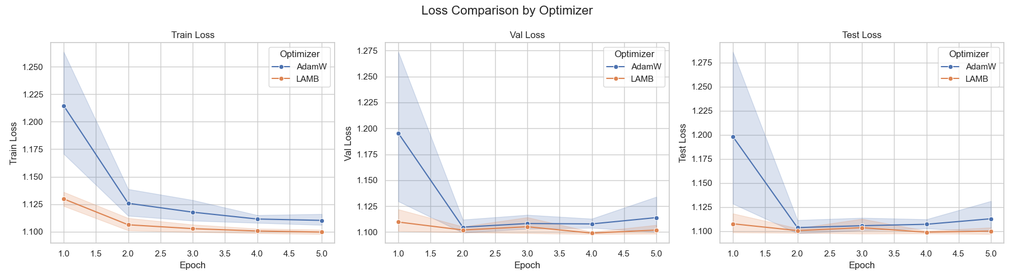

Train Acc by Optimizer

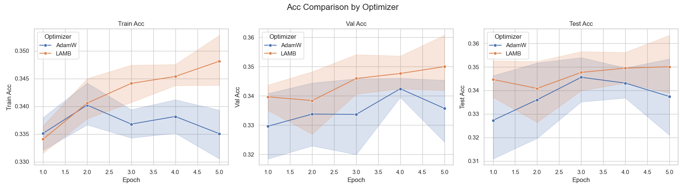

Train Precision by Optimizer

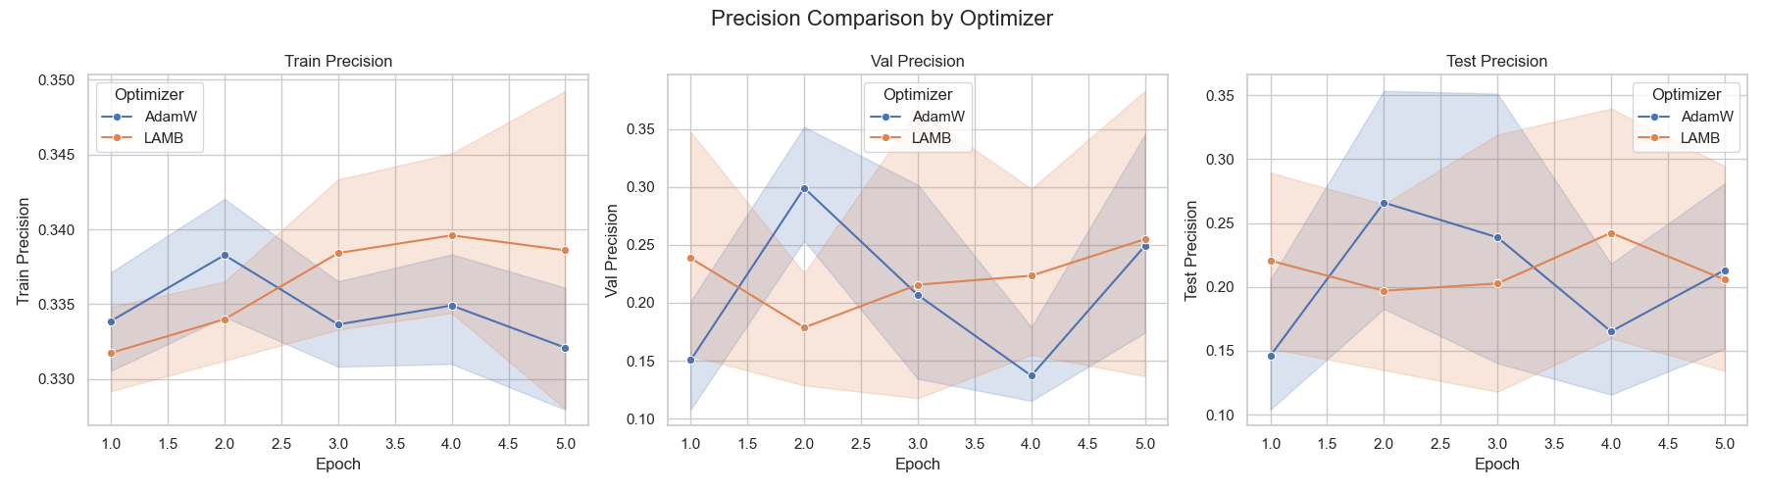

Train Recall by Optimizer

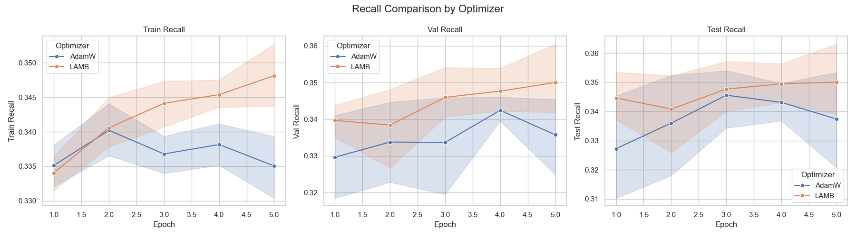

Train F1 Score by Optimizer

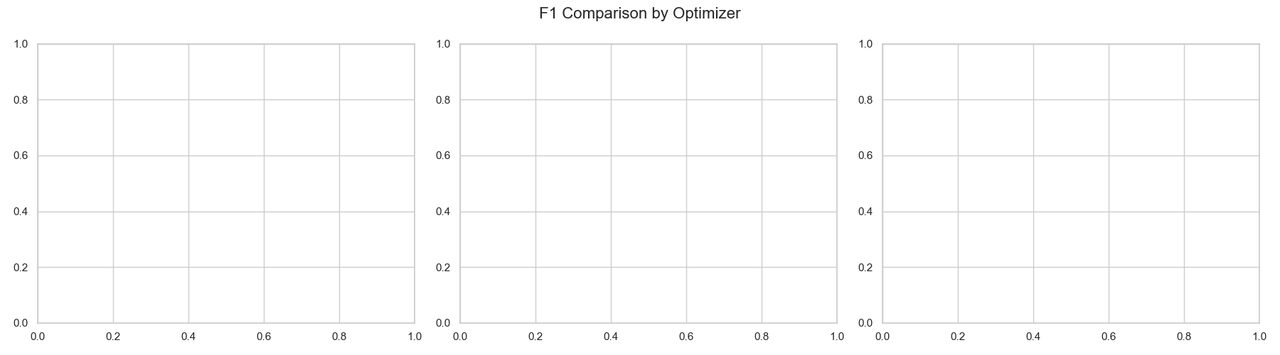

Train ROC AUC by Optimizer

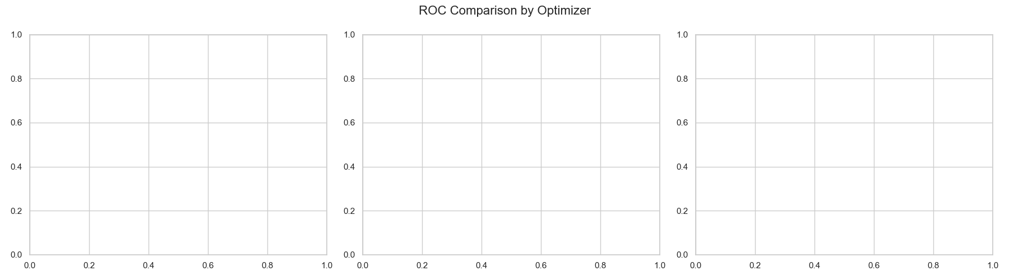

Train RMSE by Optimizer

